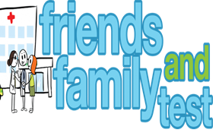
HAVE YOUR SAY TO IMPROVE YOUR CARE!
COMPLETE OUR SHORT QUESTIONNAIRE ON HOW LIKELY YOU ARE TO RECOMMEND OUR SURGERY TO FAMILY AND FRIENDS.
We have been collecting your replies and below are our results for
October 23
Very Good | Good | Neither Good/nor poor | Poor | Very Poor | Don’t Know
25 | 3 | 3 | 0 | 0 | 0

Recent comments:
- Excellent response to my needs and giving me peace of mind.
- Simply the best!
- The doctors are amazing as are the receptionists, nothing too much trouble.
- Always Helpful.
- Excellent Surgery.

